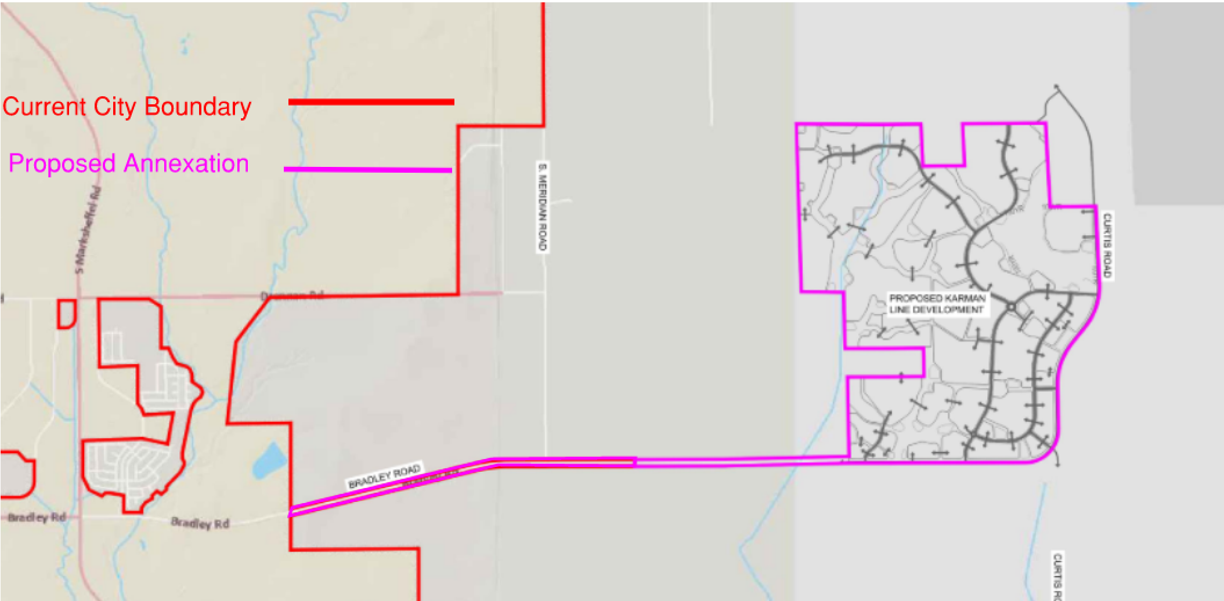
Quick Facts
Applicant
Vertex
Property Owner
Right-of-Way, City of Colorado Springs
Private Property, Norris Ranch Joint Venture, LLC
Address / Location
Northwest of Bradley Road and Curtis Road intersection
TSN(s) 4500000135, 4500000091, 4400000454, 4400000326, 4400000269
Zoning and Overlays:
Current: Unincorporated El Paso County
Proposed: A/SS-O (Agriculture with Streamside Overlay)
Site Area
1912.62 acres
Proposed Land Use
Residential – Low, Medium and High Density, Mixed-Use, Commercial, Light Industrial, Civic, Open Space, Parks, Public Safety
Applicable Code
UDC
Project Summary
This project includes concurrent applications for annexation, establishment of zoning(s), and a Land Use Plan for the associated 1,912.62-acres located northwest of the Bradley Road and Curtis Road intersection. The land use plan illustrates the proposed land use configuration, access and circulation, intended infrastructure and overall intent. The proposed zoning will establish an A/SS-O (Agriculture with Streamside Overlay) zone district with the overall annexation to allow for a flag-pole annexation consisting of 151.88 acres as City owned rights-of-way and 1,760.74 of the developer owned property (see “Project Statement – Annexation, Project Statement – Zone Establishment, and Project Statement – Land Use Plan” attachments).

File Number | Application Type |  | Decision Type
ANEX-23-0009-0014  ZONE-23-0009  MAPN-23-0002 |  | Annexation  Zone Establishment  Land Use Plan | Legislative  Legislative  Legislative

Background
Site History
As the City has expanded over the last several decades, we can see larger areas of annexation throughout our City history. During the 1980’s the City experienced a very active period of annexation including areas of North Gate, Briargate and Banning Lewis Ranch. In the early 2000’s we see the annexation of Flying Horse. Much of these areas have now been developed; however, there are existing areas of greenfield that still exist, particularly in Banning Lewis Ranch. (see ‘City Annexations by Decade’ map)

The proposed annexation is located northwest of Bradley Road and Curtis Road intersection. The proposed annexation area is currently within El Paso County and is mostly vacant, with some minor abandoned buildings remaining on the southwest corner of the property. The overall site comprises of several El Paso County zone districts (see ‘County Zone Exhibits’ attachment) and is situated in an area of residential development within El Paso County.

El Paso County’s master plan – “Your El Paso County Master Plan” – identifies the subject area as an area of ‘Potential Annexation’ on the Key Areas Map. This map identifies areas of the County that are defined by “unique localized characteristics having influence on future land use and development.” The master plan discusses that significant portions of the County’s expected development population growth will locate in surrounding incorporated municipalities. It further states that, as the largest municipality, the City of Colorado Springs will need to annex parts of unincorporated County to plan for and accommodate new development. This Key Areas Map also outlines portions of the County that are anticipated to be annexed. In addition, the subject site is classified as ‘New Development’ in the Areas of Change” analysis of the Your El Paso Master Plan. The plan states these areas are expected to be significantly transformed as projected new development takes place on lands currently largely designated as undeveloped or agricultural areas. It is further anticipated that these areas of change will see development similar to that already established or complementary to an urban neighborhood.

In combination with the above approach from Your El Paso Master Plan, in 2021 the City of Colorado Springs and El Paso County entered into an Intergovernmental Agreement (IGA) for review of development and evaluation of possible annexations. The IGA memorialized the shared vision that it is best practice for logical extensions of urban level developments to be within the City. The IGA also established an Area of Planning Interest Map (running north to south about 3+ miles east of existing City limits), which establishes a collaborative protocol for the County to notify the City of new development with that area. Karman Line Annexation is within this Area of Planning Interest.

Prior Land-Use History and Applicable Actions
Action | Name | Date
Annexation | Current Proposal | N/A
Subdivision | Final Plat Required Prior to Building Permit | N/A
Master Plan | N/A | N/A
Prior Enforcement Action | N/A | N/A

Applicable Code
The subject application(s) were submitted after the implementation date (06/05/2023) of the ReTool project. The subject application(s) were be reviewed under the Unified Development Code. All subsequent references within this report that are made to “the Code” and related sections are references to the Unified Development Code.
Surrounding Zoning and Land Use
Adjacent Property Existing Conditions (see ‘County Zoning Map Depictions’ attachment)
 | Zoning | Existing Use | Special Conditions
North | Unincorporated El Paso County | Single-family detached, northeast Shriever Space Force Base | N/A
West | Unincorporated El Paso County | Mostly vacant, one (1) single-family detached | N/A
South | Unincorporated El Paso County | Vacant | N/A
East | Unincorporated El Paso County | Vacant adjacent, with Single-family detached further east | N/A
Zoning Map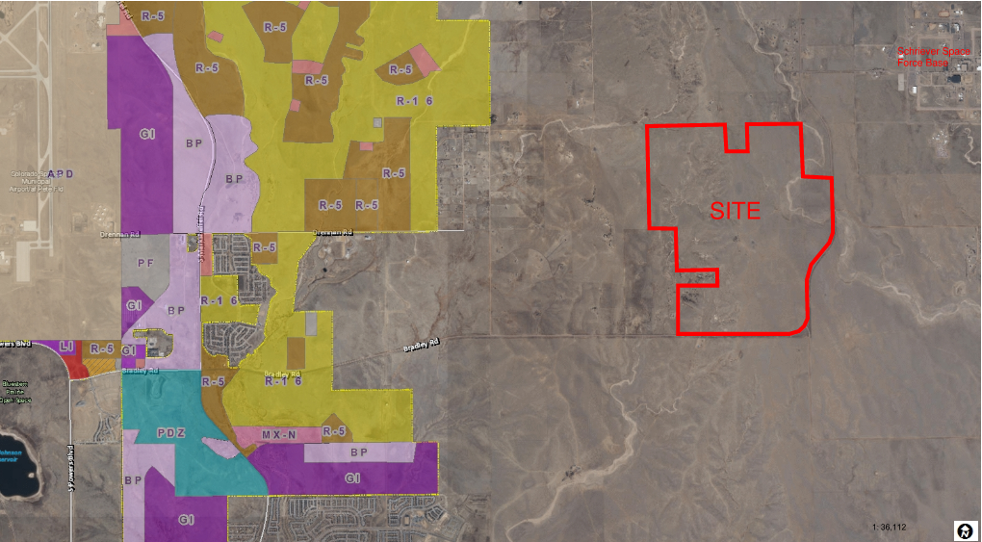

Stakeholder Involvement
Public Notice
Public Notice Occurrences  (Poster / Postcards) | Initial Submittal, Neighborhood Meeting, and prior to Public Hearings, poster and postcards required
Postcard Mailing Radius | 1,000 feet
Number of Postcards Mailed | 21
Number of Comments Received | 3 (see “Public Comments” attachment)
Timeline of Review
Initial Petition Acceptance | September 27, 2022
Post-Petition Submittal Date | April 5, 2023
Annexation Checkpoint | October 7, 2024
Updated Petition Acceptance | December 10, 2024
Number of Review Cycles | 7
Item(s) Ready for Agenda | November 19, 2024
Agency Review
Traffic Impact Study
- Traffic Engineering reviewed the Traffic Impact Study (TIS) and determined that the TIS was complete and provided the adequate information and analyses per the requirements of the Traffic Criteria Manual and Traffic Engineering staff. The applicant will be responsible for the TIS recommended traffic mitigation measures and roadway improvements.
- Bradley Road will need to be eventually 6 lanes with the finishing of this project, and Curtis Road will be required to built to City standards. The developer is required to provide for these improvements, as illustrated within the Annexation Agreement.
- Future traffic report will be needed to analyze future phases and associated roadway improvements.

School District
The Land use Plan depicts 30.1 acres for future school sites. Ellicott School District 22 has provided a letter of support (see ‘School District Letter of Support’ attachment).

Parks
This Land Use Plan went before Parks Advisory Board on November 9th and December 14th 2023, with Parks Advisory Board voting to recommend approval of the Karman Line Land Use Plan, reflecting 79.3 acres of Park Land Obligation, as detailed by PLDO code 7.4.307, with seven metro district owned neighborhood parks and one community park to be dedicated to the City provided to satisfy the obligation. Separate from the Park Land Obligations, the Jimmy Camp Creek Regional Trail, currently a future El Paso County Regional Trail, is proposed to run through the Karman Line Land Use Plan. The Karman Line Metro District(s) proposes to build, own, and maintain the regional trail detailed to the Parks Department trail standards, while providing public access via easements.
SWENT
Future development plans will require final drainage reports to be reviewed and approved by SWENT prior to land disturbance. Further coordination between the applicant, the City of Colorado Springs, and El Paso County to determine the appropriate scope of subsequent drainage studies and reports is expected.
Colorado Springs Utilities
Springs Utilities has completed an extensive four-service utility (water, wastewater, natural gas and electric) analysis to determine how the Karman Line property and proposed development would be best served upon annexation. Provision of Springs Utilities’ four services would entail design and construction of significant infrastructure and facilities, with associated costs shared by Springs Utilities and the applicant. Springs Utilities would primarily be responsible for providing resources and funding, design and constructing regional improvements. Currently, Springs Utilities is preparing a Financial Impact Analysis, which will be presented at the upcoming City Council hearings. Additionally, Springs Utilities has attempted to address and mitigate identified risks, including water quality concerns, stranded assets and required reduction of Greenhouse Gas Emissions by establishing corresponding requirements and providing constructive notice to the applicant in the Annexation Agreement.

Colorado Springs Fire Department
The proposed Karman Line annexation has been reviewed by the Fire Department and discussions have been on-going that include the likely need for a temporary fire station as well as one to possibly two fire stations at a time to be determined by the Colorado Springs Fire Department. Property for the temporary station will be jointly determined by the fire department and the developer when services are deemed necessary. At the time the temporary station is no longer required due to the construction of a permanent station, the land will be reverted back to the developer. Land will be provided by the developer for the construction of said permanent stations with the physical station, equipment and staffing to be provided by the City. At the time this development is annexed, the fire department will provide services as necessary. Due to this property’s location, response times will be significantly increased until resources are placed within the development per the annexation agreement language.
Colorado Springs Police Department
CSPD continues to have concerns about response times to annexation plats, with long distances from existing police sectors and resources. Response times cannot be calculated at this time; however, it must be noted that they may be lengthy even for higher priority calls. Attention to police staffing, both sworn, and civilian, must be a continual priority. Our ability to respond to questions accurately regarding police services in proposed annexation areas is directly affected by the number of personnel we have available to respond to requests for police services. As our city continues to grow, both in population and land size, we are committed to keeping our community safe and providing excellent police services.
Annexation
Summary of Application, ANEX-23-0009, ANEX-23-0010, ANEX-23-0011, ANEX-23-0012, ANEX-23-0013, ANEX-23-0014

The associated annexation follows the voluntary annexation rights under C.R.S. (Colorado Revised Statute) and owners must petition the municipality to request annexation into the City. The City’s authority to annex land is established by Colorado Revised Statues (CRS. 31-12-101) which sets requirements and procedures which municipalities must follow. A property is eligible for annexation if the contiguity requirement is met; not less than one-sixth the perimeter of the proposed area for annexation is contiguous with the existing boundary of the annexing municipality, and that area proposed for annexation has more than 50% ownership within the City 3-Mile Buffer for annexation, an exemption for the 3-mile rule is that if the proposal is located with an Enterprise Zone it may exceed the 3-mile buffer (see ‘3-Mile Buffer’ attachment). The proposed annexation consists of a flag-pole annexation and is located within an Enterprise Zone meeting these requirements.
Flagpole Annexation
The proposed area for development, as the real property of the annexation, does not currently have contiguity with the current City boundary. A flagpole annexation allows the property owner to configure a series of annexations, that meet the state statute required contiguity, and use a roadway as a ‘flagpole’ to gain contiguity (Colorado Revised Statute 31-12-105(e.3)). (see ‘Karman Line Additions’ attachment) Per Colorado Revised Statute a property owner may achieve required contiguity by annexing a public street. In this case the Karman Line Annexation additionally had to meet the requirements in place with the Water Ordinance of 25% contiguity. The applicant updated their original petitioned plats, not including any more land than was originally proposed, but drew new areas to meet the 25% contiguity required by this ordinance. With this configuration Additions No. 1-5 are annexing right-of-way only and Addition No. 6 has a portion of right-of-way with the remainder as real property. This extends the City boundary along Bradley Road and allows for contiguity to be gained for Addition No. 6.

The proposed annexation is located northwest of Bradley Road and Curtis Road intersection. The properties gain access by either Bradley Road or Curtis Road. The general use of the area is Schriever Space Force Base to the northeast, large lot single-family detached units adjacent to the north and west, vacant/open space to the south and east.
The owner has identified future intentions for residential, commercial, and light industrial development. Staff believes the proposed development shows appropriate compatibility when evaluated with the established surrounding land use pattern; the supporting land use plan also captures development layout and design and clearly identifies the intended land use configuration.

Application Review Criteria
UDC Section 7.5.701
- The area proposed to be annexed is a logical extension of the City's boundary;

- The development of the area proposed to be annexed will be beneficial to the City. Financial considerations, although important, are not the only criteria and shall not be the sole measure of benefit to the City;

- There is a projected available water surplus at the time of request;

- The existing and projected water facilities and/or wastewater facilities of the City are expected to be sufficient for the present and projected needs for the foreseeable future to serve all present users whether within or outside the corporate limits of the City;

- The annexation can be effected at the time the utilities are extended or at some time in the future;

- The City shall require as a condition of annexation the transfer of title to all groundwater underlying the land proposed to be annexed. Should such groundwater be separated from the land or otherwise be unavailable for transfer to the City, the City, at its discretion, may either refuse annexation or require payment commensurate with the value of such groundwater as a condition of annexation. The value of such groundwater shall be determined by the Utilities based on market conditions as presently exist;

- All rights of way or easements required by the Utilities necessary to serve the proposed annexation, to serve beyond the annexation, and for system integrity, shall be granted to the Utilities. Utilities, at the time of utility system development, shall determine such rights of way and easements;

- If the proposed annexation to the City overlaps an existing service area of another utility, the applicant shall petition the PUC (Public Utilities Commission) or other governing authority to revise the service area such that the new service area will be contiguous to the new corporate boundary of the City.

- After the foregoing have been studied in such depth as the City Council shall require, the City Council in its discretion may annex or not annex the proposed area. In the event the City Council chooses to annex, it may require a contemporary annexation agreement specifying the installation and the time of installation of certain public and utility improvements, both on site and off site, that are required or not required under this Zoning Code. City Council may specify such other requirements, as it deems necessary. In the event the City Council chooses not to annex, utilities shall not be extended unless Council is assured that an agreement for annexation can be enforced, and that the remaining provisions of this section for annexation subsequent to extension of utilities have been met.

There has been significant analysis and consideration by the City and CSU whether or not City and CSU services can be efficiently and effectively provided to the future residents and businesses ultimately living and located within the Karman Line Annexation – not only the immediate installation of infrastructure, but also ongoing future maintenance and requirements. Should the annexation be approved by the City Council, staff believes that the Annexation Agreement addresses infrastructure needs. There has been significant financial analysis prepared by CSU on the cost sharing of initial installation of CSU infrastructure, minimizing risk to “stranded assets and ongoing maintenance costs.

The one question that is more challenging to objectively answer is whether or not this annexation is a “logical extension of City boundary”. This is a City Code consideration, not a Colorado Revised Statute mandate. City Code does not define or help reach a conclusive answer to what constitutes a “logical extension”. A correlation could be made – if not only an assumption – that if an annexation is within the 3-mile boundary as required by CRS, or an exemption as provided by CRS and services can be provided, that the annexation could be considered logical. Other factors to consider include:

- Can the land between existing City boundary and the proposed annexation be annexed in the future (essentially infilled?)
- Is the annexation necessary for projected growth of the City?
- What is the remaining developable land within existing City boundary?
- What if the land is not annexed? Will development occur outside the City boundary anyway? What are the impacts to the City of development occurs “right outside” the City boundary?
- Can the City effectively and efficiently provide on-going services such as snowplowing, code enforcement, park maintenance, etc.?

Should the Planning Commission support the Annexation, and should the City Council ultimately wish to approve the Annexation, staff believes that the Annexation Agreement adequately addresses many of these topics. It should be noted that the area between the existing City limits and the Karmen Line Annexation is mostly developed as rural-residential and suburban-level residential with some non-residential uses. It is unlikely that this area will be annexed into the City in the near to mid-term future.
City Annexation Plan (2006)
The current City Annexation Plan was last updated in 2006 and is currently being updated through the AnnexCOS project. This 2006 plan does not contemplate the subject site for a potential annexation into the City of Colorado Springs. The cornerstone of the annexation evaluation through this plan points to the comprehensive plan, PlanCOS, that directs a focus on diversification of economic base and the City’s ability to accommodate projected population increases leading to positive outcomes for annexation into the City. AnnexCOS is anticipated to recommend a strategic approach to logical annexations that supports and encourages significant areas of newly planned urban density development to be included within City limits, in order to promote the long-term fiscal and resource sustainability of the City and region.
Fiscal Impact Analysis
A Fiscal Impact Analysis (FIA) is required for all annexations. Due to the magnitude of the proposed annexation the City Economic Development Department worked with the City Budget Office and has consulted with an outside agency, Data Driven Economic Strategies (DDES), to conduct a Fiscal Impact Analysis. The FIA concludes that the Annexation will result in net positive cumulative and annual fiscal impact over a 10-year and 20-year buildout (see ‘Fiscal Impact Analysis’ attachment).
Southeastern Colorado Water Conservancy District (SECWCD)
This property has completed its required inclusion application into the Southeastern Colorado Water Conservancy District through the Bureau of Reclamation. The Inclusion process will be completed with the Bureau of Reclamation with a final Letter of Assent pending.

Zone Establishment
Summary of Application, ZONE-23-0009
The proposed zoning request is to establish an A/SS-O (Agriculture with Streamside Overlay) zone district to accommodate the future development (see ‘Exhibits A&B’ attachment). It is required by City Code that any annexed property be accompanied by a zoning designation. If the petitioner chooses, they can establish an A (Agriculture) zone district as a ‘holding zone’ to proceed through the annexation process; further request for zone change is required when a final development intent is determined. Overall intent is for the annexation area to be annexed with the supporting land use plan and through future Land Use or Development Plans, the owner will apply for a specific zoning designation in conformance with the land use plan. This is a fairly common practice for large annexations which are then evaluated for compliance with the master plan and can allow for future specific zoning action for development. It is also captured in the Karman Line Annexation Agreement that future zoning actions will be required (see ‘Draft Annexation Agreement’ attachment).

Application Review Criteria
UDC Section 7.5.704
An application for an amendment to the zoning map shall be subject the following criteria for approval:
- The proposed rezoning is consistent with the goals and policies of the Colorado Springs Comprehensive Plan, with other plans and policies adopted by the City Council; and with the purpose statement of the proposed zone district.

- The rezoning will not be detrimental to the public interest, health, safety, convenience or general welfare.
development is compatible to the existing residential within the vicinity.
- The location of the lands in the zoning map area being amended are appropriate for the purposes of the proposed zone district(s).

- If the application proposes to rezone a small area of land, the application demonstrates that the size, scale, height density, and multimodal traffic impacts of the proposed rezoning are compatible with surrounding development or can be made compatible with surrounding development through approval conditions.

- If the application proposes to rezone a relatively small area of land, the application demonstrates that the change in zoning will not create significant dislocations of tenants or occupants of the property, or that any impacts are outweighed by other public benefits or progress toward other Colorado Springs Comprehensive Plan goals that would be achieved by approval of the application.

- If a Land Use Plan or amendment to a Land Use Plan accompanies the application, the Land Use Plan or amendment complies with the applicable criteria in Subsection7.5.514C.3 (Land Use Plan Criteria).

- The application is consistent with any approved Concept Plans in the area for which the map is being amended or includes or is accompanied by a provision that the approved Concept Plans have been classified as implemented and do not have to be amended to be considered consistent with an amended zoning map.

- If the application is for creation of an ADS-O district, the approval criteria applicable to the creation of the text of the ADS-O district in Section 7.2.607D.4 (Decision) shall also apply to consideration of the zoning map amendment required to create or amend the boundaries of the ADS-O district.

- If rezoning to a PDZ district, the proposed PDZ district provides significant community amenities or other benefits, as determined by the Manager, that promote the achievement of Colorado Springs Comprehensive Plan goals and would not otherwise be required of the applicant under this UDC or other City or governmental regulations.

- Complies with the additional standards of the base zone district where the property is located (see Article 7.2 (Zone Districts)) or in an overlay district that applies to the property (see Part 7.2.6 (Overlay Districts)).

Staff finds that the criteria of UDC Section 7.5.704, which are applicable to a zoning establishment, have been met with this application.
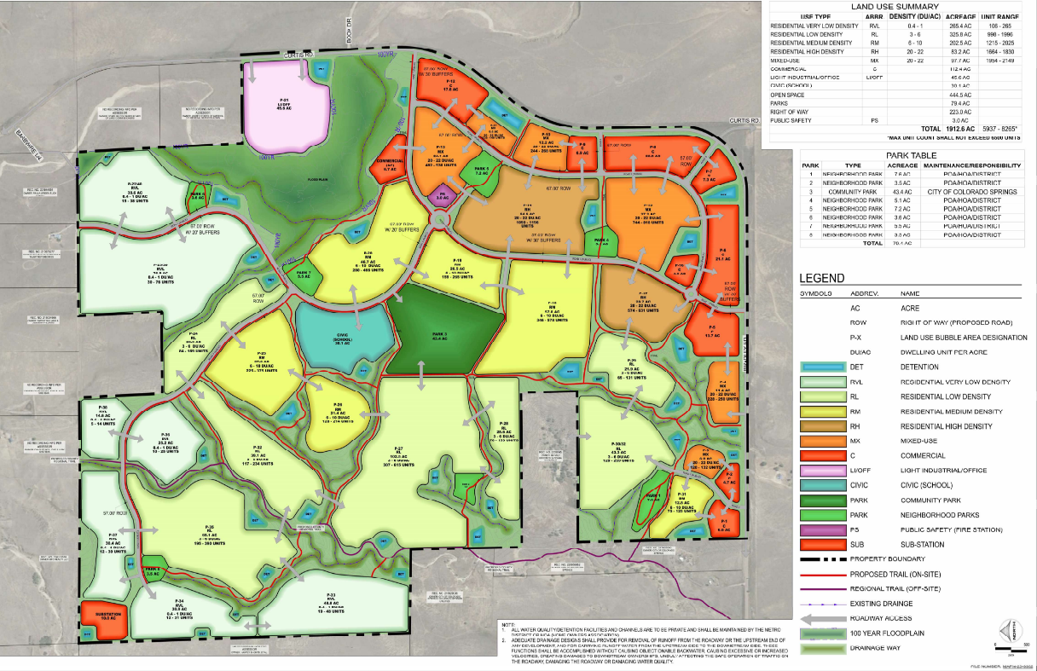
Land Use Plan
Summary of Application, MAPN-23-0002
Per Section 7.5.302.A of the Code, A Land Use Plan is a plan required in some circumstances to show the proposed layouts of land uses, development intensities and densities, primary access points, green space, public open space systems and areas that should be preserved or protected, potential needs for public land dedications, and other aspects of proposed development at a conceptual level. The purpose of a Land Use Plan is to provide the City the information needed to evaluate how a proposed development may impact surrounding development without requiring the applicant to provide the levels of detail required on a Development Plan (see ‘Karman Line Land Use Plan’ attachment).

Application Review Criteria
UDC Section 7.5.514
Land Use Plan Criteria: If the Land Use Plan is submitted in connection with an application to establish a zone district or to change zone district boundaries shall be reviewed based on the following criteria:
- Consistency with the Colorado Springs Comprehensive Plan and other plans and policies adopted by City Council;

- Consistency with development standards the zone district in which the property is located, or would be located after a requested zone district change;

- Compatibility with the land uses and development intensities surrounding the property;

- Impacts of the permitted or requested uses, appropriate to the type of development, the neighborhood, and the community;

- Adequacy of proposed ingress/egress points and traffic circulation, both on and off the site;

- Capacity of the existing streets, utilities, parks, schools, and other public facilities to serve the proposed development;

- Promotion of transitions in height, intensity, or character between proposed non-residential or mixed-use development and nearby low-density residential zone districts.

Staff finds that the above criteria are met for the Land Use Plan.
Compliance with PlanCOS
PlanCOS Vision
When the City’s Comprehensive Plan (PlanCOS) was drafted in the 2017 and 2018 timeframe, and then adopted in early 2019, it did not directly contemplate an annexation scenario comparable to this one. However, PlanCOS does recommend an update of the City’s Annexation Plan to accommodate more strategic annexations along the periphery of the City “that support economic growth or expansion of the regional roadway network.” PlanCOS also recommends that this Annexation Plan update evaluate annexation polices “to be consistent with the vision, goals and policies of this plan and in coordination with the Colorado Springs Utilities, El Paso County, and other municipalities”. In this respect it is noteworthy that the El Paso County Master Plan (Your El Paso Master Plan) identifies the Karman Line Annexation area as having the potential for annexation, and as an area of change for suburban level development as discussed above.

PlanCOS is oriented around six major themes, Vibrant Neighborhoods, Unique Places, Thriving Economy, Strong Connections, Renowned Culture, Majestic Landscapes. In the context of this proposed development the Comprehensive Planning Division comments on these applications have focused on the proposed development plans for the Karman Line Annexation project. The expectation is that, until the intervening areas between this property and the currently developed areas of the City become annexed and developed, it will be contingent upon this project to address and satisfy certain of the PlanCOS goals and objectives based on “self-contained” approach. From a development planning perspective, staff believe the applicant’s development approach and its refinements have been responsive to these considerations.
Vibrant Neighborhoods
As a large master planned development, this project has the potential to result in one or more vibrant neighborhoods consistent with PlanCOS Chapter 2 Typology 4: Future Neighborhoods; by planning for and incorporating a diversity of housing types, neighborhood parks and gathering places, connections to regional trails and open space, and future multi modal connections. With its designation of mixed-use centers, providing various housing options which can support ranging densities and price points, and incorporation of stream corridor open space, the design of the master plan sets up the potential to accomplish the goal of vibrant neighborhoods.
Unique Places
The future mixed-use centers and designated residential areas create a potential for the future creation of unique places consistent with Chapter 3 Typology 1: Neighborhood Centers and Typology 2: Community Activity Centers
Strong Connections
Several of the major streets have the potential to incorporate key recommendations of Chapter 5 Typology 3: Recent Suburban Streets. These aspects include connections with and incorporation of separate facilities for bikes and pedestrians, landscaping and screening of medians and parking areas, and connections with the local sidewalk and trail network. These facilities could also be designed to incorporate the latest future “smart streets” technology and have the potential for future “transit-ready” adaptation.
Renowned Culture
The school sites designed into this plan have the potential to satisfy many of the recommended attributes of Chapter 6 Typology 2: Community Assets, including increased connections to the surrounding neighborhoods as well as serving as focal points for community engagement.
Majestic Landscapes
This land use plan has incorporated a number of aspects of Chapter 7 Typology 5: Greenways including integration of natural drainageways, associated trails and corridors, public access and integration of stormwater and flood mitigation best practices. Both Jimmy Camp Creek and Williams Creek have been proposed with the intent of functioning as “complete creeks in greenways” as contemplated in PlanCOS.
Statement of Compliance
ANEX-23-0009 through ANEX-23-0014, Karman Line Addition No 1-6
After evaluation staff recognizes that the proposed annexation meets the eligibility requirements set forth in Colorado Revised Statutes; however, determination of compliance with Conditions of Annexation as set in City Code is at the discretion of City Council.
ZONE-23-0009
After evaluation of the proposed Zone Establishment of the A/SS-O (Agriculture with Streamside Overlay) zone district the application meets the review criteria.
MAPN-23-0002
After evaluation of the Karman Line Land Use Plan the application meets the review criteria.

